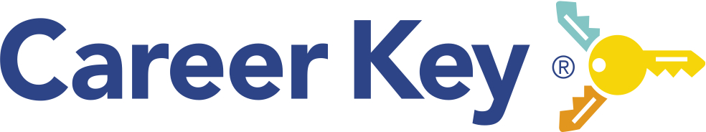

Lesson Planning
Career Key Assessments & Follow Up Activities

Depending on your course schedule, you can combine these activities into one or two class periods or space activities out across multiple days – some can be done remotely (watching videos, taking the CDP) on a mobile phone. The learning activities are optional and enable students to further explore how to connect their personality type with careers and education programs that fit.

You may administer one or both assessments, but we recommend having students take the 5-minute Career Decision Profile (CDP) once before your career exploration activities, including Career Key Discovery (CKD). That way you will know more about your students’ unique needs for future lesson planning. You can also decide later whether to ask students to retake it as a post measure.

You may wish to familiarize yourself with the CDP and CKD by …
- Watching the CDP Video Overview: https://vimeo.com/480498917
- Watching the CKD Video Overview https://vimeo.com/393492821
- Taking CDP and CKD yourself to see the student perspective (as well as the reports).
- Watching a video About CKD’s decision tools https://vimeo.com/409021237

Instruction:

1. Introduction to Career Key (15 minutes)
  - Introductory Power Point Slides: Take Career Decision Profile, Take Career Key Discovery, Introduction to Career Key
  - Watch Overview Video: Career Decision Profile https://vimeo.com/480498917 (2:10 minutes)
  - Take Career Decision Profile (5 minutes)

2. Taking Career Key Discovery (20-30 minutes)
- Watch Overview Video: Career Key Discovery https://vimeo.com/392542053 (2.25 minutes)
- Watch video: Career Key Discovery Decision Tools https://vimeo.com/409021237 (4:25 minutes)
- Share the link to the Career Key Discovery assessment
- Students will progress through these sections: (10 minutes)
1. Welcome: Student sign in - first name, last name, email
2. Take Assessment – (allow 5-10 minutes)
3. Assessment Results – students learn about their thriving, promising and challenging environments; and their top 2-3 RIASEC Types (Realistic, Investigative, Artistic, Social, Enterprising, Conventional)
4. Explore Careers and Majors – students explore thriving and promising careers and college majors/training programs - and bookmark or save ones that interest them
5. Career Profile – a summary of their assessment results and saved careers and majors
- Note: Students can sign in later to “Explore Careers and Majors”

3. Follow up Learning Activities: Students explore 2-3 careers in their strongest personality types.
- PowerPoint: Finding My Fit - Student Handout with Group Activity (30-45 min)
- Explore Texas Career Pathways – Student Handout with Online Activity (20-30 min)

4. Reflection and Closing (10 minutes)
  - Students retake Career Decision Profile or Post-Assessment Survey
  - Discuss the Reflection questions (2-3 minutes)
- Send the Parent Letter home to support student and parent discussions on their career and college major explorations and next steps.

Welcome Kit - Teaching Resources

Videos
- Teacher: Career Key Overview ( https://vimeo.com/393492821)
- Students: Career Decision Profile (https://vimeo.com/480498917)
- Students: Career Key Discovery (https://vimeo.com/392542053)
- Students: CKD Profile Decision Tools (https://vimeo.com/409021237)

Student Materials
- Parent Letter (pdf)
- Student Surveys
  - Career Decision Profile
OR
  - Pre-Assessment Survey (pdf)
  - Post Assessment Survey (pdf)
- Career Key Discovery web application
- Student Activity:
  - Find Your Fit – Group Activity
  - Explore (Texas Careers) – Individual Activity

Instructional Tools:
- PowerPoints
  - Take Career Decision Profile
  - Take Career Key Discovery
  - Introduction to Career Key Discovery
  - Find Your Fit - Group Activity

