Career Decision Platform

Implementation Planning Guide

for Workforce & Business

Overview – combine assessments to maximize benefits
Get to know your clients or employees better, faster

With Career Key, your clients or employees (clients) take a snapshot of where they are on their career decision journey so they can make progress. At the same time, they gain life- and career-changing insights about what they need to make confident career decisions. They identify their top personality, interests, skills and values—and then use this information to identify best fit career options and postsecondary programs where they will thrive.

Career Key’s career decision platform combines two scientifically valid assessments,
- the 5-minute Career Decision Profile (CDP) measure of career decision status, and
- the 10-minute Career Key Discovery (CKD) interest inventory based on Holland’s Theory,
whose results are all displayed in the group administration portal, Career Key Central.
You can administer either one on its own, but we recommend administering both to maximize their benefits.
For maximum benefit, consider making a pre/post “sandwich”, where a client’s 1st CDP completion (pre-intervention) is the bottom slice of bread, the intervention (CKD) is the filling, and their 2nd CDP completion (post-intervention) is the top slice of bread.
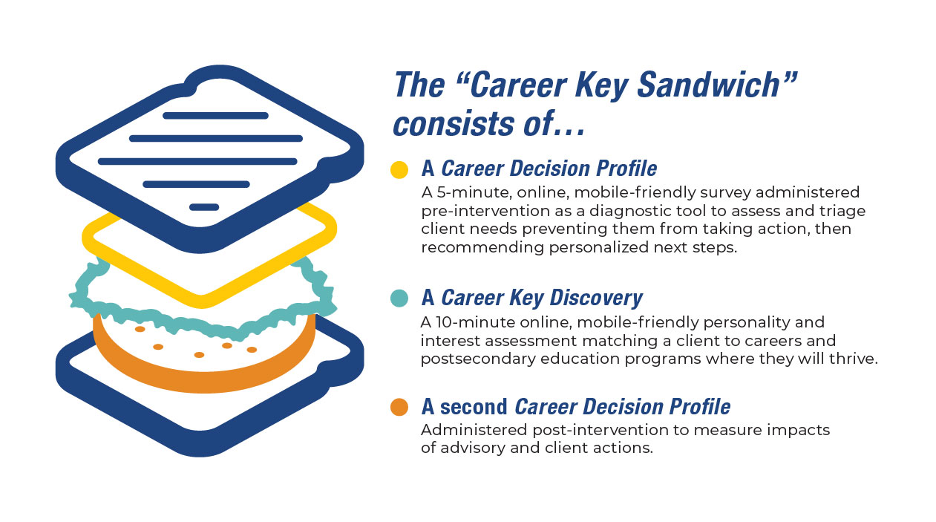
You get data to measure the impact of Career Key Discovery and your activities on clients’ career development, and clients get to share what’s changed for them as a result of the activity. All with 5 minutes of additional client time retaking the CDP.
Key Facts: How the Career Decision Profile assessment works
- Takes clients about 5 minutes to complete the inventory
- Mobile and tablet friendly
- Self-interpreting, individualized explanation of assessment results, recommended next steps to keep making progress on their decision-making journey
- Clients receive a shareable PDF report with results and their recommended next steps
- Advisors see estimated levels of service for each client in Career Key Central, in addition to detailed results
- Pre and post intervention administration provides scientifically valid data on multiple dimensions of career decision status including:
  - Decidedness
  - Comfort
  - Self-Clarity
  - Knowledge of Careers and Education Options
  - Decisiveness
  - Career Choice Importance
  - Existence of barrier(s) (Capacity for Progress)
  - Other Factors (optional fill-in)

Key Facts: How the Career Key Discovery assessment works
- Takes clients about 10 minutes to complete the inventory
- Mobile and tablet friendly
- Self-interpreting, individualized explanation of assessment results, including which environments the client will find thriving, promising, and challenging
- Clients can filter and explore best-fit careers and education programs by education required, duration, type of award
- Clients receive a shareable PDF report with results and their selected options

Research shows that a close fit between a client’s Holland personality types and postsecondary education programs predicts higher grades, persistence in a program and higher on-time graduation rates.

Shared Learning Goals
Practical goals advisors have shared with us include…
- Help clients explore how they feel about where they are, and understand they are supported
- Understand quickly how ready each client is to make a decision about a career or education program
- Learn more about clients' unique decision needs, including other factors not otherwise known to the advisor
- Increase clients’ awareness of themselves – their interests, personality, and values,
- Help clients relate their personal characteristics to occupations and education programs,
- Expand the career options and education programs clients are considering,
- Stimulate clients’ career exploration, such as, discussing possible careers and training programs with others and doing online research,
- Help clients create an individualized learning plan or personal graduation plan
- Increase clients’ confidence in their ability to make good career decisions
- Gather data about their interventions and how they are making a difference for clients
Career Key meets professional standards in career readiness competencies, such as
- National Association of Colleges and Employers (NACE) Career Competencies
Step by Step Implementation
Below we describe three steps to implementation. The Workforce and Business Welcome Kit contains all client and advising materials mentioned below.
Step 1. Preparation
- Decide when taking the Career Decision Profile (CDP) and Career Key Discovery (CDP) assessments fit into your program.
- Review the Welcome Kit materials and adapt resources as needed.
- Sign into Career Key Central to explore its features. Bookmark it for easy return. Career Key’s kickoff webinar will go over important features and answer questions.
- Watch video overviews of the platform and the two assessments.
- You may wish to take the Career Decision Profile and Career Key Discovery assessments yourself to see the client perspective (as well as the PDF reports). The web location for each assessment is located in Career Key Central, under the righthand gear icon selection “Organization Info> Technical.”
- Optional: Administer Career Decision Profile pre-intervention to measure changes in clients’ pre and post career decision readiness
Step 2. Client Engagement
- Optional: Administer the CDP to clients prior to their taking Career Key Discovery.
- Provide clients with the link to take the Career Key Discovery Assessment.
- Optional: Post Assessment Learning Activities
  - Find My Fit – group activity on the six Holland RIASEC Types/ Work Groups
Step 3. Reflection: Gather and Share Data
- Optional:
  - Administer the Career Decision Profile post-intervention
  - Group Discussion: Clients share their responses to the CDP
- Optional: Want clients to learn more online after taking the assessment? Go to the Resources section of Career Key’s website and click on Fit.
Additional Advising Resources for Career Key’s group administration portal Career Key Central include
- Tips for advising clients
- Create and manage groups of clients/clients
- Custom and template email follow up via built in messaging function
- Easy set-up with your team and other departments for larger scale collaboration
- Export data for use in other systems via .csv

