Career Decision Platform

Implementation Planning Guide

for High School

Overview – combine assessments to maximize benefits
Get to know your high school students better, faster as they build their college and career plans

With Career Key, your students take a snapshot of where they are on their career decision journey so they can make progress. At the same time, they gain life- and career-changing insights about their readiness to make career decisions, personality, interests, skills and values—and then use this information to identify best fit career options and postsecondary programs where they will thrive.

Career Key’s career decision platform combines two scientifically valid assessments,
- the 5-minute Career Decision Profile (CDP) measure of career decision status, and
- the 10-minute Career Key Discovery (CKD) interest inventory based on Holland’s Theory,
whose results are all displayed in the group administration portal, Career Key Central.
You can administer either one on its own, but we recommend administering both to maximize their benefits.
For maximum benefit, consider making a pre/post “sandwich”, where a student’s 1st CDP completion (pre-intervention) is the bottom slice of bread, the intervention (CKD) is the filling, and the student’s 2nd CDP completion (post-intervention) is the top slice of bread.
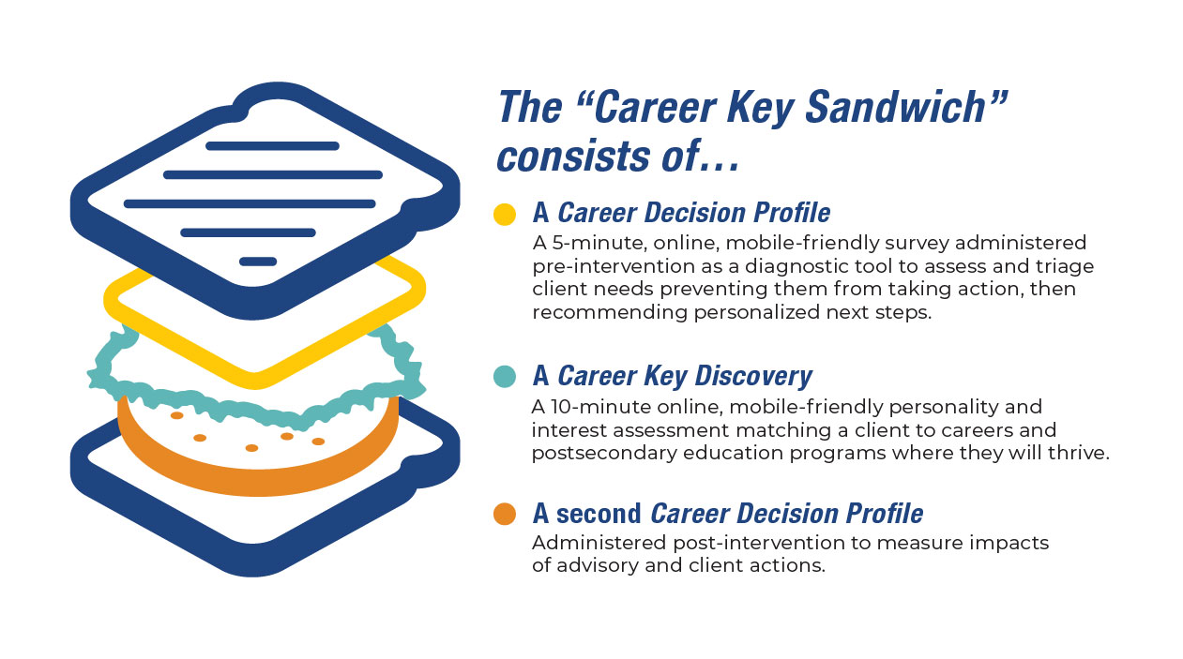
You get data to measure the impact of Career Key Discovery and your activities on students’ career development, and students get to share what’s changed for them as a result of the activity. All with 5 minutes of additional student time retaking the CDP.
Key Facts: How the Career Decision Profile assessment works
- Takes students about 5 minutes to complete the inventory
- Mobile and tablet friendly
- Self-interpreting, individualized explanation of assessment results, recommended next steps to keep making progress on their decision-making journey
- Students receive a shareable PDF report with results and their recommended next steps
- Advisors see estimated levels of service for each student in Career Key Central, in addition to detailed results
- Pre and post intervention administration provides scientifically valid data on multiple dimensions of career decision status including:
  - Decidedness
  - Comfort
  - Self-Clarity
  - Knowledge of Careers and Education Options
  - Decisiveness
  - Career Choice Importance
  - Existence of barrier(s) (Capacity for Progress)
  - Other Factors (optional fill-in)

Key Facts: How the Career Key Discovery assessment works
- Takes students about 10 minutes to complete the inventory
- Mobile and tablet friendly
- Self-interpreting, individualized explanation of assessment results, including which environments the student will find thriving, promising, and challenging
- Students receive a shareable PDF report with results and their selected options
- High school students explore careers, majors and education pathways.

Research shows that a close fit between a student’s Holland personality types and postsecondary education programs predicts higher grades, persistence in a program and higher on-time college graduation rates.

Shared Learning Goals
Practical goals teachers and administrators have shared with us include…
- Help students explore how they feel about where they are, and understand they are supported
- Get to know students better, more quickly
- Increase students’ awareness of themselves – their interests, personality, and values,
- Help students relate their personal characteristics to occupations and education programs,
- Expand the career options and majors students are considering,
- Stimulate students’ career exploration, such as, discussing possible careers and training programs with others and doing online research,
- Help students create an individualized learning plan or personal graduation plan
- Increase students’ confidence in their ability to make good career decisions
- Gather data about their interventions and how they are making a difference for students
Meets American School Counseling Association (ASCA) Mindsets and Behaviors, as part of its professional counseling National Model for College and Career Readiness (2019). See our chart mapping them and student competencies to Career Key’s resources for more details.
Step by Step Implementation
Below we describe three steps to implementation. The Welcome Kit contains all student and teacher materials mentioned below.
Step 1. Preparation
- Decide when taking the Career Decision Profile (CDP) and Career Key Discovery (CDP) assessments fit into your course schedule.
- Review the Welcome Kit materials and adapt resources as needed.
- Sign into Career Key Central to explore its features. Bookmark it for easy return. Career Key’s kickoff webinar will go over important features and answer questions.
- Watch video overviews of the platform and the two assessments.
- You may wish to take the Career Decision Profile and Career Key Discovery assessments yourself to see the student perspective (as well as the PDF results reports). The web location for each assessment is located in Career Key Central, under the righthand gear icon selection “Organization Info> Technical.”
- Optional: Administer Career Decision Profile pre-intervention to measure changes in students’ pre and post career and education perspectives.
Step 2. Student Engagement
- Send the Parent letter home to engage parents in supporting their students’ experience.
- Optional: Administer the CDP to students prior to their taking Career Key Discovery.
- Provide students with the link to take the Career Key Discovery Assessment.
- Optional: Post Assessment Learning Activities
  - Find My Fit – group activity on the six Holland RIASEC Types/ Work Groups
  - Explore Texas [Your State] Career Pathways – individual activity sourcing relevant state information
Step 3. Reflection: Gather and Share Data
- Optional:
  - Administer the Career Decision Profile post-intervention
  - Group Discussion: Students share their responses to the CDP
- Optional: Want students to learn more online after taking the assessment? Go to the Resources section of Career Key’s website and click on Fit.
Additional Teaching Resources for Career Key’s group administration portal Career Key Central include
- Tips for advising students
- Create and manage groups of students/clients
- Custom and template email follow up via built in messaging function
- Easy set-up with your team and other departments for larger scale collaboration
- Export data for use in other systems via .csv

